**For Loops and while loop Unit 1**

**For loop**

* A For Loop is used when you know how many times you want the code to run.
* A For Loop has a start.
* A for Loop has an end.

For is the keyword

i is the variable which stores the data

In range (0,5) 0 is the start number 5 is the end point of the loop

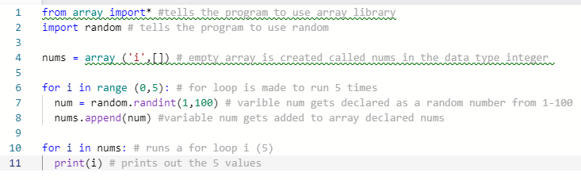



**While loop**

* A while loops is used when you don’t know how many times the code will run.
* Used to check if an input meets certain rules.
* Used to make a process repeat until a rule is met.

A while loop used the same rile as am of statement – we use comparison operators